Multi-Valued Attribute

🌟 Definition
# Source: AI Source: Provided by: [Data Path: Persons Table -> ID Column: 1, Name_En Column: Motasem Essam] -> From: [ChatGPT] on [6/10/2026]
A Multi-Valued Attribute is an attribute that can have more than one value for a single entity.
Unlike a simple attribute, which stores only one value, a multi-valued attribute can store multiple values of the same type.

🎯 Purpose
# Source: AI Source: Provided by: [Data Path: Persons Table -> ID Column: 1, Name_En Column: Motasem Essam] -> From: [ChatGPT] on [6/10/2026]
Multi-valued attributes are used when:
- An entity can have multiple instances of the same information
- A single value is not sufficient
- Multiple values naturally belong to one entity

🧠 Simple Example
# Source: AI Source: Provided by: [Data Path: Persons Table -> ID Column: 1, Name_En Column: Motasem Essam] -> From: [ChatGPT] on [6/10/2026]
Entity
Customer
Attribute
Phone Numbers
A customer may have:
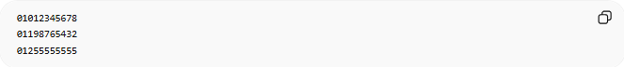
01012345678
01198765432
01255555555
Since one customer can have several phone numbers, Phone Numbers is a Multi-Valued Attribute.

📚 Real-World Examples

1. Phone Numbers
# Source: AI Source: Provided by: [Data Path: Persons Table -> ID Column: 1, Name_En Column: Motasem Essam] -> From: [ChatGPT] on [6/10/2026]
Customer
└── Phone Numbers
Values:
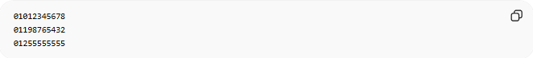
01012345678
01198765432
01255555555

2. Email Addresses
# Source: AI Source: Provided by: [Data Path: Persons Table -> ID Column: 1, Name_En Column: Motasem Essam] -> From: [ChatGPT] on [6/10/2026]
Employee
└── Email Addresses
Values:
work@example.com
personal@example.com

3. Skills
# Source: AI Source: Provided by: [Data Path: Persons Table -> ID Column: 1, Name_En Column: Motasem Essam] -> From: [ChatGPT] on [6/10/2026]
Employee
└── Skills
Values:

PHP
JavaScript
SQL

4. Languages
# Source: AI Source: Provided by: [Data Path: Persons Table -> ID Column: 1, Name_En Column: Motasem Essam] -> From: [ChatGPT] on [6/10/2026]
Person
└── Languages
Values:
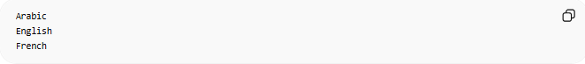
Arabic
English
French

🔢 Characteristics of a Multi-Valued Attribute
# Source: AI Source: Provided by: [Data Path: Persons Table -> ID Column: 1, Name_En Column: Motasem Essam] -> From: [ChatGPT] on [6/10/2026]
A multi-valued attribute:
- Can contain multiple values
- Belongs to one entity
- Often requires a separate table in relational databases
- Represents repeating information

📊 ER Diagram Representation
# Source: AI Source: Provided by: [Data Path: Persons Table -> ID Column: 1, Name_En Column: Motasem Essam] -> From: [ChatGPT] on [6/10/2026]
In an ER diagram, a multi-valued attribute is often shown using a double oval.
Example:
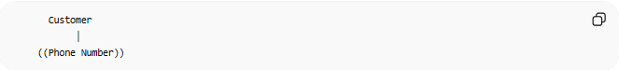
Customer
│
((Phone Number))
The double parentheses represent a multi-valued attribute.

🗄️ Database Example
# Source: AI Source: Provided by: [Data Path: Persons Table -> ID Column: 1, Name_En Column: Motasem Essam] -> From: [ChatGPT] on [6/10/2026]
Conceptual Model
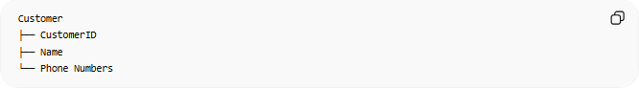
Customer
├── CustomerID
├── Name
└── Phone Numbers

Relational Database Design
Instead of storing multiple phone numbers in one column:
❌ Bad Design
CustomerID | Name | PhoneNumbers
1 | Ali | 01012345678,01198765432

✅ Better Design
# Source: AI Source: Provided by: [Data Path: Persons Table -> ID Column: 1, Name_En Column: Motasem Essam] -> From: [ChatGPT] on [6/10/2026]
Customers Table
CustomerID | Name
1 | Ali
CustomerPhones Table
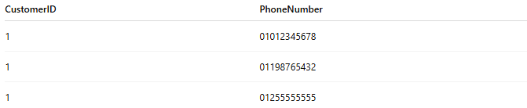
CustomerID | PhoneNumber
1 | 01012345678
1 | 01198765432
1 | 01255555555
This follows database normalization principles.

🌍 Student Example
# Source: AI Source: Provided by: [Data Path: Persons Table -> ID Column: 1, Name_En Column: Motasem Essam] -> From: [ChatGPT] on [6/10/2026]
Entity
Student
Multi-Valued Attribute
Hobbies
Values:
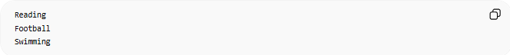
Reading
Football
Swimming
One student can have many hobbies.

⚠️ Multi-Valued Attribute vs Simple Attribute
# Source: AI Source: Provided by: [Data Path: Persons Table -> ID Column: 1, Name_En Column: Motasem Essam] -> From: [ChatGPT] on [6/10/2026]
Simple Attribute
Age
One value only.
Example:
25

Multi-Valued Attribute
Phone Numbers
Many values.
Example:
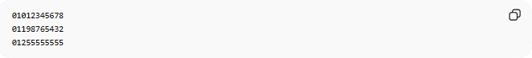
01012345678
01198765432
01255555555

Comparison
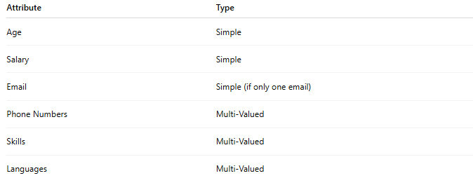
Attribute | Type
Age | Simple
Salary | Simple
Email | Simple (if only one email)
Phone Numbers | Multi-Valued
Skills | Multi-Valued
Languages | Multi-Valued

⚠️ Multi-Valued Attribute vs Composite Attribute
# Source: AI Source: Provided by: [Data Path: Persons Table -> ID Column: 1, Name_En Column: Motasem Essam] -> From: [ChatGPT] on [6/10/2026]
Composite Attribute
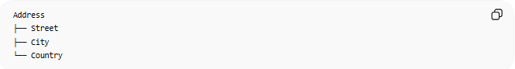
Address
├── Street
├── City
└── Country
One attribute divided into parts.

Multi-Valued Attribute
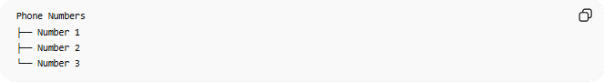
Phone Numbers
├── Number 1
├── Number 2
└── Number 3
Multiple occurrences of the same type of value.

📚 More Examples
# Source: AI Source: Provided by: [Data Path: Persons Table -> ID Column: 1, Name_En Column: Motasem Essam] -> From: [ChatGPT] on [6/10/2026]
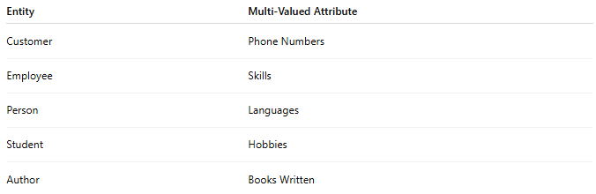
Entity | Multi-Valued Attribute
Customer | Phone Numbers
Employee | Skills
Person | Languages
Student | Hobbies
Author | Books Written

🧠 Simple Analogy
# Source: AI Source: Provided by: [Data Path: Persons Table -> ID Column: 1, Name_En Column: Motasem Essam] -> From: [ChatGPT] on [6/10/2026]
Think of a contact in your phone:
Ali
The contact may have:
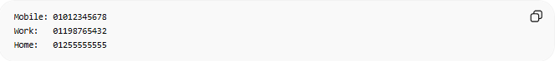
Mobile: 01012345678
Work: 01198765432
Home: 01255555555
One person, multiple phone numbers.
Therefore, Phone Numbers is a Multi-Valued Attribute.

🧭 Summary
# Source: AI Source: Provided by: [Data Path: Persons Table -> ID Column: 1, Name_En Column: Motasem Essam] -> From: [ChatGPT] on [6/10/2026]
A Multi-Valued Attribute is an attribute that can hold multiple values for a single entity. Examples include Phone Numbers, Skills, Languages, and Hobbies. In relational databases, multi-valued attributes are usually implemented using a separate table to store the multiple values efficiently and correctly.

